Grant Grummer

9/6/2020

Starlite Assembly Instructions

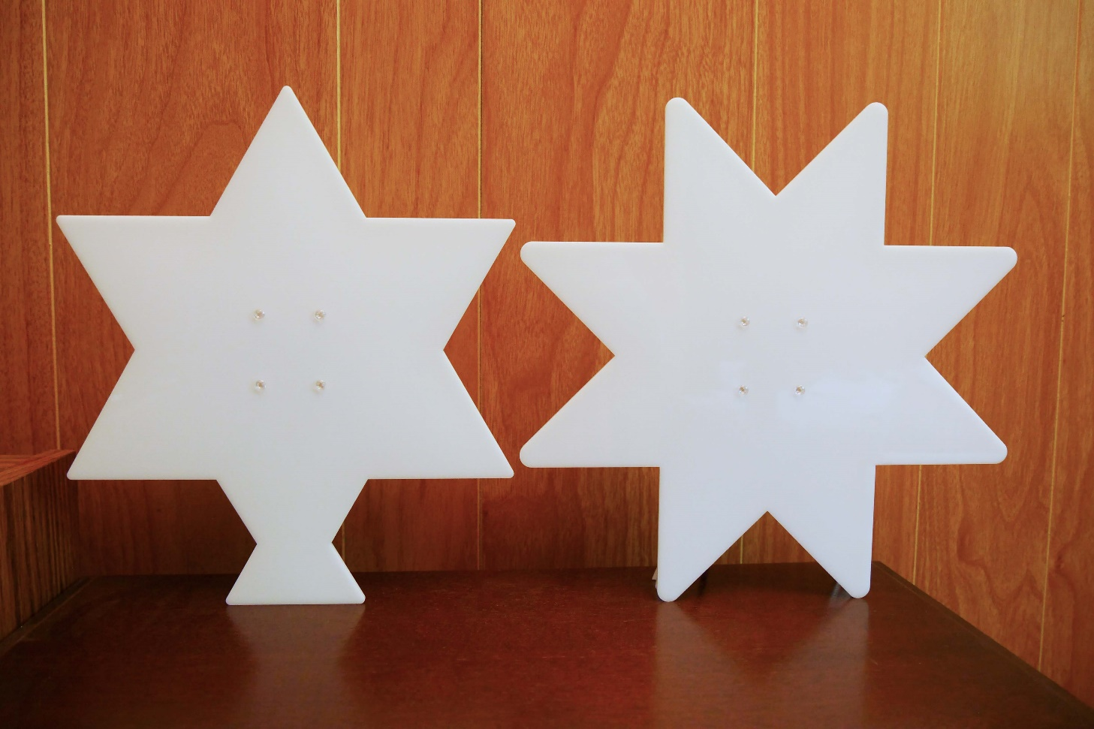

Revision: A.0

Table of Contents

Introduction 1

Tools required 1

Assembly Instructions 1

Quick Instructions (for those who don’t like detailed instructions) 1

Detailed, Step by Step Instructions 2

Optional 3D Printed Back Cover 7

# Introduction

These instructions cover how to build a 6 or 8-point Starlite. Both are approximately 10 inches tall. They consist of outer and inner translucent acrylic stars shapes, tri-color LED strips, a circuit board, and the hardware to connect them together. An optional 3D printed back cover can also be made, for a more finished look.

It is assumed that all the parts, listed in the Starlite parts list, have been acquired before starting this assembly process.

# Tools required

The following list of tools are needed to build a Starlite:

* Soldering iron with a narrow tip (0.015” to 0.031” recommended)
* Thin solder (.031” to .020” recommended)
* Philips screwdriver, #1 size
* Wire cutters
* Small pliers

Though not required, solder wick is extremely handy to have available.

# Assembly Instructions

All through hole parts are used on Starlite in order to make the PCB assembly easy to do. With the exception of the 50 mil pin headers, that turns out to be correct. These pin headers require a steady hand or some decent optical magnification.

## Quick Instructions (for those who don’t like detailed instructions)

* All components are soldered onto the component side except the 50 mil pin headers
* **The shorter pins of the headers supplied with the UPduino and the USB Breakout boards must be inserted into and soldered to the StarLiteMain board, not the long pins!**
* Bend the power switch (S2) pins over some after soldering
* Solder the pin headers (onto the back of the PCB) last
* Plastic screws just need to be screwed in snug; they don’t need to be tighten much.

## Detailed, Step by Step Instructions

1. Solder the following components onto the components side of the StarLiteMain board first
   1. Capacitors: C1 – C5
   2. Diode: D1
   3. Push buttons: S1 & S3
   4. IC: U2

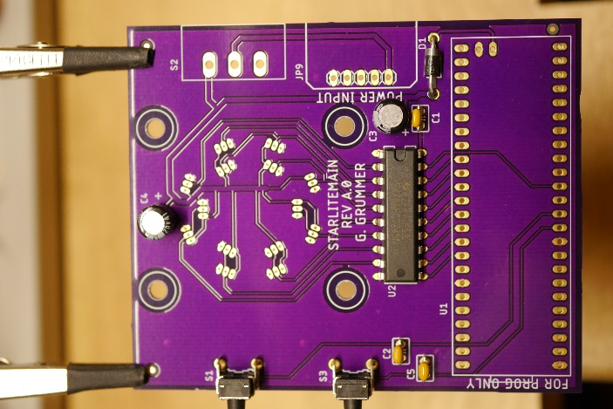

1. Apply a blob of solder across the OSC solder short on the UPduino board. It may be easier to do this step after the UPduino has been installed onto the StarLiteMain board.

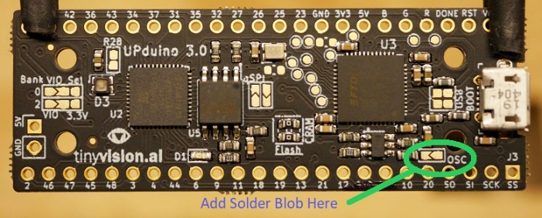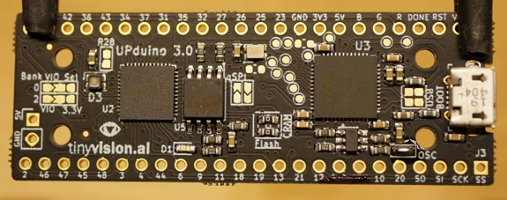

1. Solder the following components onto the components side of the StarLiteMain board next by following the instructions below.
   1. UPduino board: U1
   2. USB Micro B Breakout Board: JP9

Break off 2 header pins from one of the headers that came with the UPduino board. Insert those headers into the UPduino and StarLiteMain boards as shown in the following picture. **The shorter pins of the** **headers supplied with the UPduino board must be inserted into the StarLiteMain board, not the long pins!** The following pins on the UPduino board must be connected to the StarLiteMain board with the supplied headers. No harm will come to connecting additional pins.

* Pins 27 – GND (next to the VIO pin)
* Pins 6 – GND (next to pin 10) (GND pin is not labeled in the picture)
* Pins 5V and GND (on the opposite side of the UPduino USB connector)

Insert the header that came with the USB Breakout board into the StarLiteMain board as shown in the following picture. **The shorter pins of the** **headers supplied with the USB Breakout** **board must be inserted into the StarLiteMain board, not the long pins!**

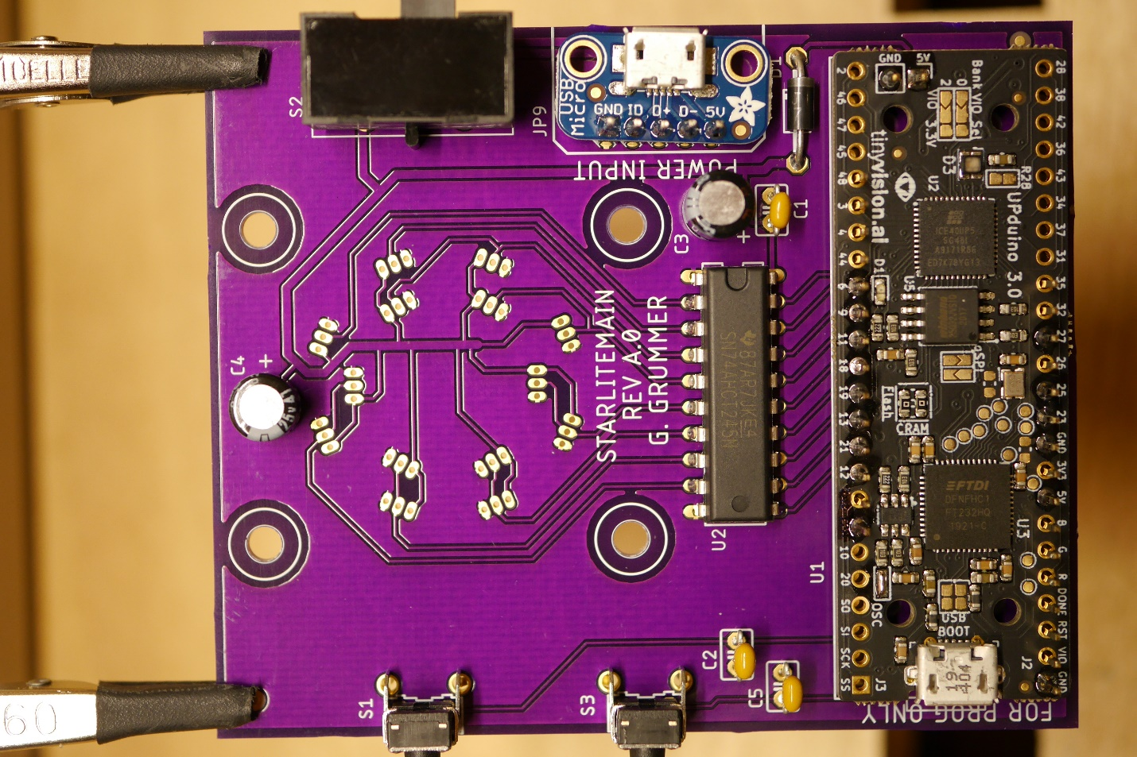

It’s easier to solder UPduino and the USB Breakout boards to the header which came with the board first, before soldering them to the PCB. Note not all of the pins on the UPduino need to be soldered (refer to the previous picture).

1. Solder the power switch (S2) to the board. Bend its pins over some (refer to the following picture)

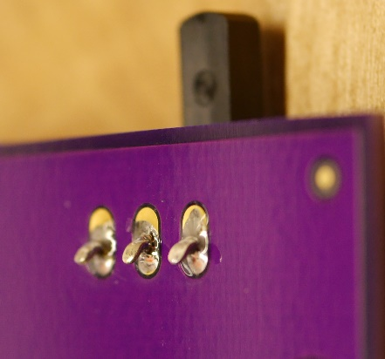

1. Install the 50 mil pin headers onto the back of the StarLiteMain board. It’s easiest to use the inner acrylic star to hold the headers to the board. Solder the pin headers to the board (refer to the following picture). Note the 8-point star configuration is shown.

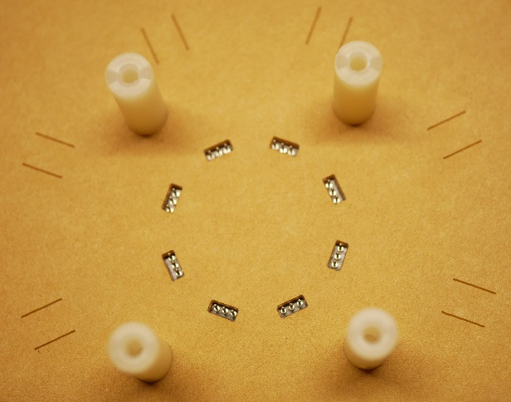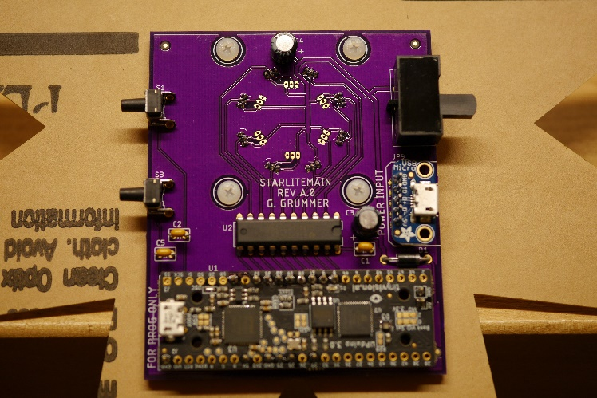

1. Remove inner star from the StarLiteMain board.
2. Remove the protective paper from both sides of the inner star. An X-Acto knife or tape will help removing the protective paper.
3. Attach inner star with guide lines on one side and the StarLiteMain board on the other side. Use screws and standoffs to hold everything in place. Try to center the pin headers in the openings in the inner star (refer to the following picture). Note the 8-point star configuration is shown.

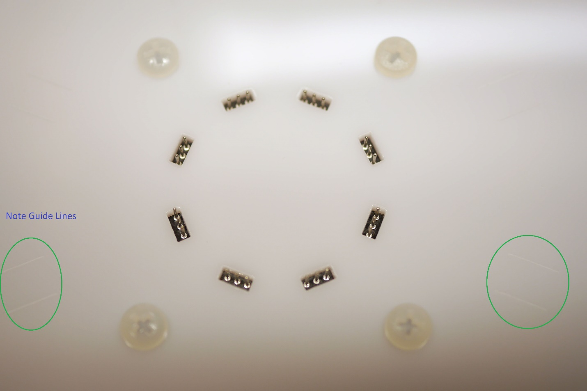

1. Cut the NeoPixel RGB LED strip into a length that has seven LEDs and seven caps. Make the cuts one the line in the middle of the exposed copper fingers. Straighten the strip the best you can.
2. Cut the exposed copper fingers off the end where the arrow point to (refer to the following picture). Pay close attention to the direction of the arrows on the strip.

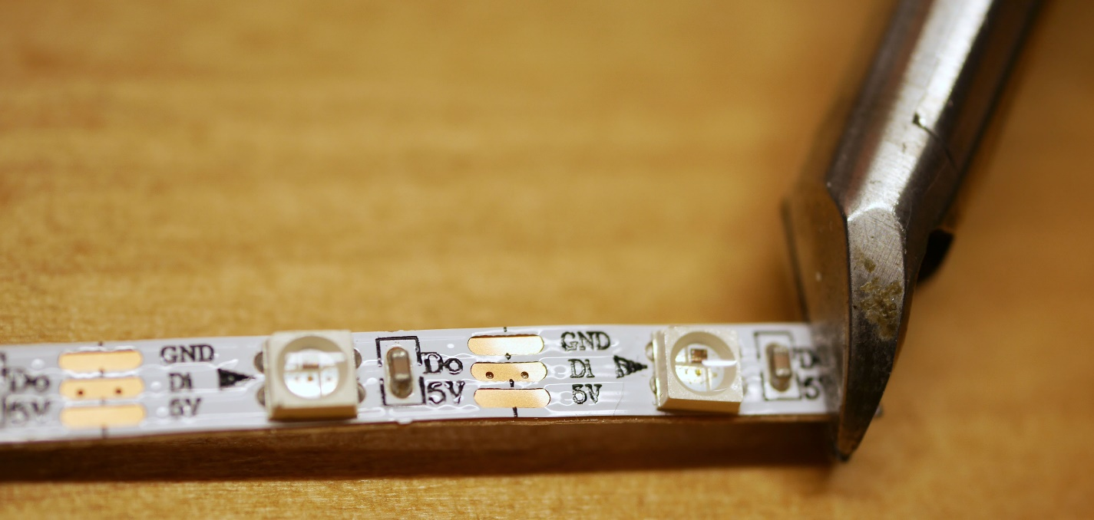

1. Make a slight bend at the exposed copper fingers at the end of the strip where the arrow points away from (refer to the following picture).

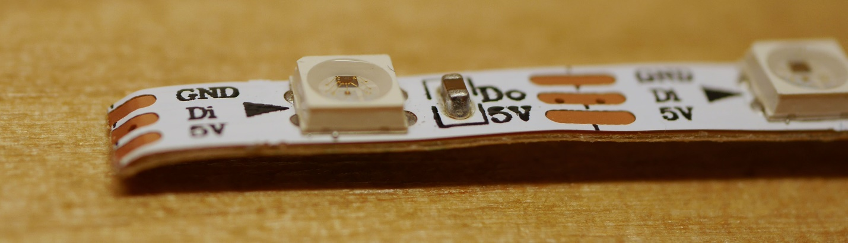

1. Start pealing the paper backing off the strip, starting at the end with the bend. Align the exposed copper fingers with a pin header so that the pins touch the exposed copper fingers. It’s OK to bend the pins a little to come closer to making contact with the fingers.
2. Use the guide lines (etched into the acrylic) to guide the placement of the strip as the paper backing is removed and the strip is attached to the acrylic (refer to the following picture).

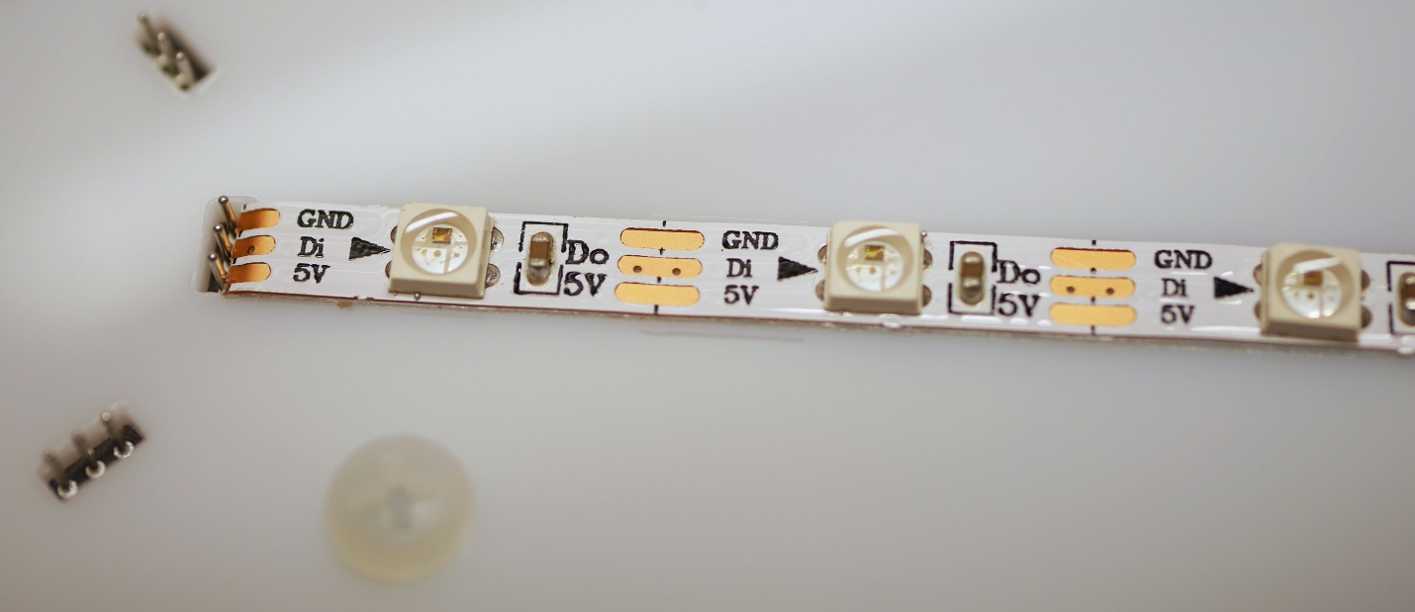

1. Repeat steps 9 through 13 until all strips have been attached.
2. Solder the exposed copper fingers to the pin headers.
3. Carefully remove screws and standoffs, one at a time, and switch the sides where they’re attached. The screw should now be on the StarLiteMain board and the standoff on the inner acrylic star. Repeat with the other three screw/standoff sets.
4. Remove the protective paper from both sides of the outer star.
5. Place the outer star on top of the standoffs and screw it on. The assembly should look like the following picture.

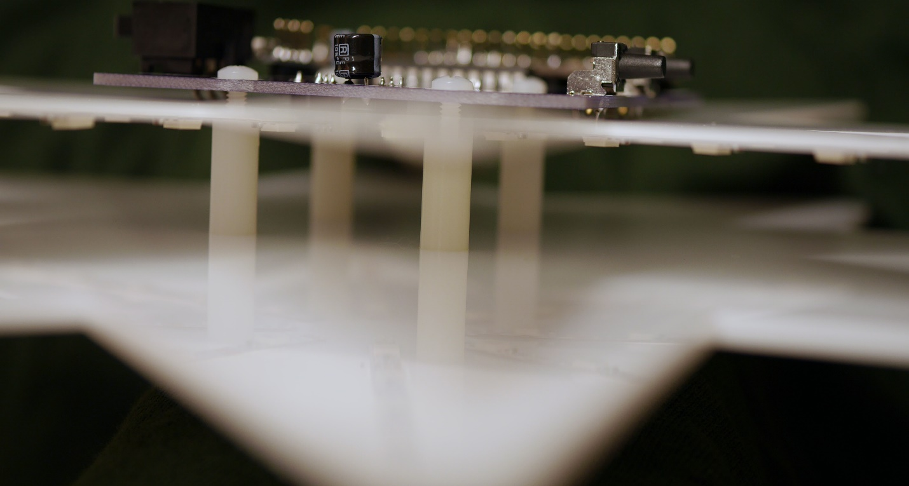

# Optional 3D Printed Back Cover

To give Starlite a more finished look, one can add a back cover. The also makes the Starlite more stable when placed standing up. Alternatively, the back cover has a feature which allows it to be mounted to a wall.

The files for the back cover are found in the “Mechanical” folder. There’s one for the 6-point and one for the 8-point designs.

The following picture shows the back cover for the 6-point Starlite. Labels were also added for clarity.

